**SPH3U 7.5 Nuclear Fusion**

1. **Mass-energy equivalence**

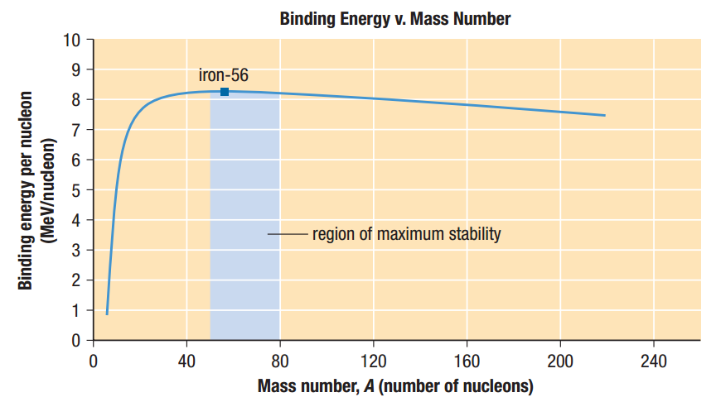

|  |  |
| --- | --- |
| Heavy nuclei: |  |
| Light nuclei: |  |
| c2: |  |

Determine the energy released when a deuterium atom (D) fuses with a tritium atom (T) to form helium, according to the nuclear reaction equation below. Use the given masses.

$${}_{1}^{2}{\text{H}}+{}_{1}^{3}{\text{H}}→{}_{2}^{4}{\text{He}}+{}_{0}^{1}{\text{n}}+\text{energy}$$

mD = 2.014 10 u

mT = 3.016 05 u

mHe = 4.002 60 u

mn = 1.008 67 u

c2 = 930 MeV/u

1. **Controlled nuclear fusion**

|  |  |
| --- | --- |
| Proton-proton chain: |  |
| Production of elements: |  |
| Carbon-nitrogen-oxygen cycle: |  |
| Magnetic confinement: |  |
| The ITER Project: |  |

**Homework:** page 347: #1-3, 5-6